

PROJECT REPORT- GROUP 5

BUSINESS PROCESS MODELING

AND DATA MANAGEMENT [OPIM- 5272]

**ROCHE UDI (UNIQUE DEVICE IDENTIFICATION) PROCESS**

**Team Supervisor: Team members:**

Prof. Anna Radziwillowicz Sahil Sikka

Suvir Gupta

Supreet Mangat

# **Contents**

1. **Project Proposal**  3
   1. Brief Background 3
   2. Business Process 3
   3. Equipment Classification 3
   4. Data Governance Process 3
   5. AS-IS Process 4
   6. Actors Involved in the AS-IS Process 5
   7. The New FDA Regulation 5
   8. Issues with the Current AS-IS Process 5
   9. Objective of the Project 6

1.10. Planning 6

1. **Data Model**  6
   1. Implementation of the To-Be Process 6
   2. Enablers for the To-Be Process 6
   3. To-Be Process 7
   4. Actors Involved in the To-Be Process 8
   5. ERD 8
2. **Physical Database Schema** 9
   1. Database Details 9
   2. Trigger Statements 11
   3. DML Statements 11
3. **Generating Insights** 12
   1. To check the no of different equipment types in DMS 12
   2. SQL to get the number of CR created for each type 3 equipment 12
   3. View to check which CR is assigned to equipment 12
   4. SQL to get the Summary of the CRs created 12
   5. Total time taken to close a change request 13
4. **Conclusion**  13
5. **References**

1. ***Project Proposal***
   1. **Brief Background**

Roche, established in 1896, with its’ headquarters at Basel, Switzerland, is a pioneer in the discovery, development, production and marketing of novel healthcare solutions. It is one of the world’s leading research-focused healthcare groups in the fields of pharmaceuticals and diagnostics. It has two major business divisions, i.e., pharmaceuticals and diagnostics (medical equipment/devices).

* 1. **Business Process**

The company follows a ‘Data Governance’ process, where by it maintains and updates the information related to all equipment it manufactures or markets in its database system. The equipment is classified into three categories, i.e., Type 1, Type 2 & Type 3.

* 1. **Equipment Classification**

The FDA classifies medical equipment or devices based on the risk they pose to the consumers:

1. **Type 1:**
2. Low to moderate risk
3. General controls
4. **Type 2:**
5. Moderate to high risk
6. General & Specific controls
7. **Type 3:**
8. High risk
9. General controls and Pre-market approval
   1. **Data Governance Process**

The components of the Business Process that is the Data Governance process of Roche are as follows:

* **Inter-related Tasks**

1. Equipment Specifications identified
2. Data Owner Assigned
3. Data Owner: Creates/Updates/Delete the required data
4. Data Approver: Validates the data

* **Triggering Event:** The triggering event is the Periodic Data Management Process of the organization which is done to satisfy all the internal and external regulations.
* **Specific Result:** The DB of the organization is updated and the required information is shared with the FDA.
* **Customer:** FDA
* **Stakeholders:** Pharma Companies, FDA, Physicians, Patients

* 1. **AS-IS Process**

Since most of the product related data is stored as Master data, company has an initial system in place to store material master data globally in Database Management System(DMS). There is material master creation, deletion and Update approval process in place for data related transactions. Apart from Basic Material data that is constituent of finished product like (BOM, material group), the Product classification data and warehousing data is also maintained in the DMS. Current Data creation process is simple and with less number of actors. There is a Product manager who analyze the material creation requirement, set timelines for material creation, and assign Data owner with task of creating material with all description and classification details. Data creation request is assigned to Data approver who can accept or reject the request.

If accepted, the corresponding data is updated in the Global Data Management System (DMS), else the data file send back to the Product Manager for re-analysis.

**AS-IS Diagram for the project is as below:**



The following is the workflow structure of the AS-IS Process:

* Product Manager checks the attributes to be created and assign the closing date to equipment Id
* Product manager assign data owner to create the FDA specified attributes
* Data owner creates data in the type 3 equipment table
* Data validator validates the data and marks the data as approved in workflow table
  1. **Actors Involved in the AS-IS Process**
* **Product Manager:** The Product Manager is accountable for analyzing the data creation, its deletion or updating the data as per requirements. The Product Manager also sets the estimated timelines of Data Creation and then passes on the data to the corresponding data owner.
* **Data Owner:** The Data Owner is responsible for basic material data creation, deletion and its update. The Data Owner segregates the data into different classifications and then passes the data to the Data Approver.
* **Data Approver:** The Data Approver is responsible for validating the contents given by the Data Owner with the same level of product info and then Approve/Reject the data.
  1. **The New FDA Regulation**

The Food and Drug Authority(FDA) has mandated all Pharma companies to label and register Type 3 equipment related data with FDA in the form of Unique Device Identification(UDI). This includes Diagnostic equipment that meets FDA prescribed classification. The goal of the UDI regulation is to establish a system that provides several benefits to industry, regulators and the public. With unique identifier code linked to the data published on web-based database by national regulatory, it helps end users (hospital, doctors and patients) to acquire device information easily and eliminate confusion that leads to inappropriate use of the device. UDI can also improve the accuracy reporting of adverse events by removing the uncertainty concerning the device that is subject of the report.

The Type 3 equipment attributes that need to be shared with the FDA are: Issuing Agency, Primary Device Identifier, Device Count, Registered Brand Name in Agency, Model Number and Packaging Type.

* 1. **Issues with the Current AS-IS Process**

To accommodate the new functionality and meet the FDA specified guidelines, the data approval process needs to be modified.

1. Current global master data base (DMS) does not have the defined data attributes as specified by FDA in product description Guide lines for UDI. New Identifiers, material number, tables and attributes need to be created or existing records need to be modified.
2. Since all Equipment’s are not required to be listed under FDA Global Unique Device Identification Database (GUDID). Only saleable IVD products, which comply with FDA class 3 definition must be reported to FDA and maintained in the Pharma companies UDI database. A separate approval process needs to be assigned to list only that equipment whose UDI validation is required.
3. It is not feasible to modify the current DMS to accommodate modification in the attributes as specified by FDA.
   1. **Objective of the Project**

In-order to comply with the new FDA Regulation, we are suggesting to create an additional database linking the company’s internal database with FDA database using the unique identifier.

* 1. **Planning**

We approached our project by the below mentioned key steps:

1. Identify the three types of equipment, i.e., Type 1, Type 2 and Type 3
2. Manually enter the equipment information in the equipment table
3. Design the basic Database and Table Structure as per the AS-IS Diagram
4. Normalize the Database to implement the new changes
5. Test the new database structure
6. ***Data Model***
   1. **Implementation of the To-Be Process**

A new data base called ‘CUDID’ (companies Unique Device Identification Database) has to be created which would receive the approved records from the current ‘Global Data Management System (DMS)’. The ‘CUDID’ database would maintain all the attributes as per the regulatory requirements and the data from the ‘CUDID’ database would then be further released to the FDA systems.

* 1. **Enablers for the TO-BE Process**
* **Workflow Design:** A new workflow should be created in-order to comply with new FDA Regulations
* **Information Systems:** User interface applications in-order to implement the workflow process
* **Human Resources:** Regulatory Department, Launch Managers, Product Managers, Data Owners, Project Managers, Data Approvers & Data Coordinator.
* **Policies and Rules**

1. The ‘Change Request’ process must be completed at least 10 days before the FDA specified deadline
2. Any system related issues need to be immediately reported to the I.T department
   1. **TO-BE Process**

UDI data processing is for regulatory submission. Wrong data would cause a new submission with a new Identifier numbers as well as material numbers. Hence, the proposed ‘To Be’ process introduces a concept of transparent data ownership and validation process.

There are some attributes currently maintained in Internal Master data system (DMS), which should be transferred to companies UDI Database. All other FDA UDI mandatory fields will be recorded in UDI database.

When compared with the AS-IS Diagram, the TO-BE Diagram has four new actors and that is the proposed system by which the company will be able to comply with the new FDA regulation.

Please find below attached TO-BE Diagram:



The following is the workflow of the To-Be process:

* Regulatory creates CR request
* Regulatory assigns data to launch manager in work flow table
* Launch Manager checks for the related attributes in DMA and email them to product Manager
* Product Manager checks the attributes to be created and assign the closing date to equipment Id
* Product manager assign data owner to create the FDA specified attributes
* Data owner creates data in the type 3 equipment table
* Product/Project Manager assigns data validator to the workflow table
* Data validator validates the data and marks the data as approved in workflow table
  1. **Actors Involved in the TO-BE Process**
* **Regulatory:** The Regulatory is responsible for creating the new CR request (change request) and assigning it to the launch manager in the work flow table
* **Launch Manager:** The Launch Manager checks for the related attributes in DMA and emails them to product Manager
* **Product Manager:** The Product Manager is accountable for analyzing the data creation, deletion and updating data as per requirements. The Product Manager also sets the estimated timelines of Data Creation and then passes on the data to the corresponding data owner
* **Data Owner:** The Data Owner is responsible for basic material data creation, deletion and updating data as per requirements. The Data Owner segregates the data into different classifications and then passes the data to the Data Approver
* **Project Manager:** The Project Manager here is the Product Manager, who is responsible for assigning the data validator to the workflow table
* **Data Approver:** The Data Approver is responsible for validating the contents given by the Data Owner with the same level of product info and then Approve/Reject the data

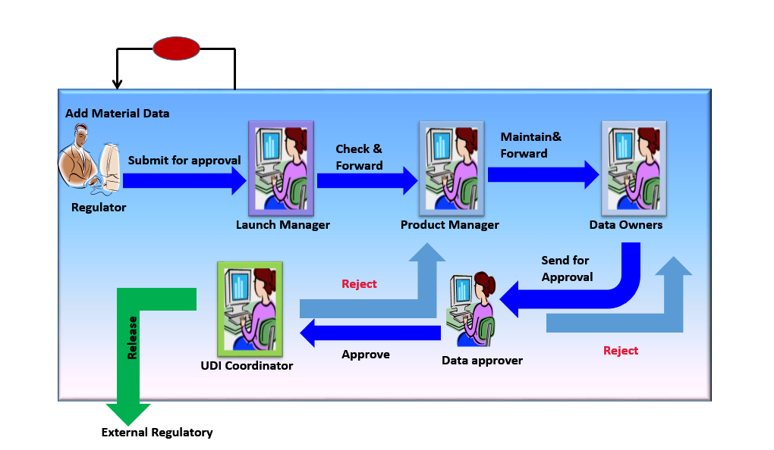

**Picture: Depiction of TO-BE- Process with Actors**

* 1. **ERD**

The Entity Relationship Diagram displays all the tables and their corresponding relationships, as have been implemented in the database.

Please find below attached ERD Diagram.

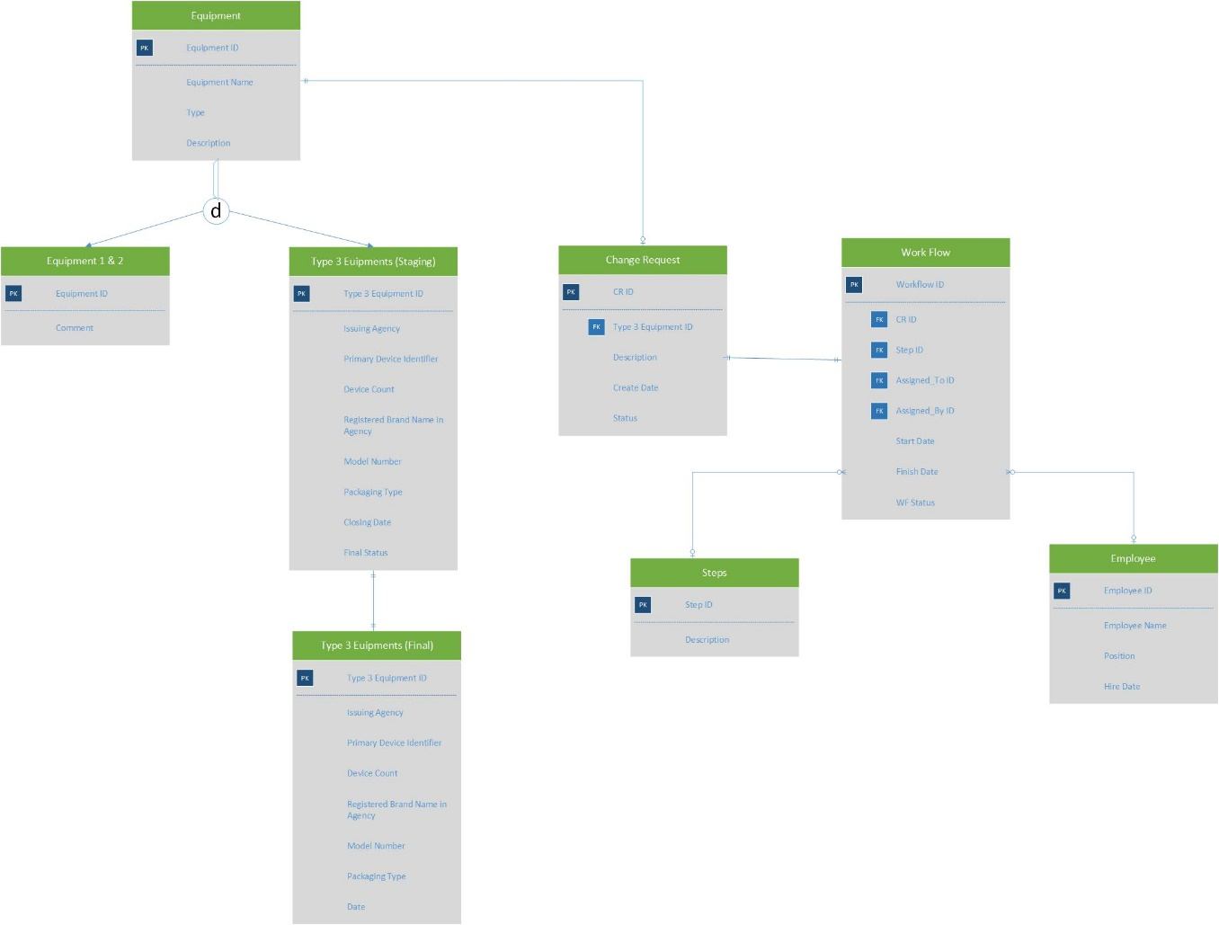

1. ***Physical Database Schema***
   1. **Database Details**

The new Database created for the implementation for the FDA regulation is as follows:

**TABLE 1: EQUIPMENT**

|  |  |  |
| --- | --- | --- |
| EQUIPMENT | | |
| EQUIPMENT_ID | INTEGER | PRIMARY KEY |
| EQUIPMENT_NAME | VARCHAR (500 BYTES) | - |
| TYPE | INTEGER | - |
| DESCRIPTION | VARCHAR (500 BYTES) | - |

**TABLE 2: EQUIPMENT_ONE**

|  |  |  |
| --- | --- | --- |
| EQUIPMENT | | |
| EQUIPMENT_ID | INTEGER | PRIMARY KEY |
| COMMENTS | VARCHAR (500 BYTES) | - |

**TABLE 3: TYPE_3_EQUIPMENTS_STAGING**

|  |  |  |
| --- | --- | --- |
| TYPE_3_EQUIPMENTS_STAGING | | |
| TYPE_3_EQUIPMENT_ID | INTEGER | PRIMARY KEY |
| ISSUING_AGENCY | VARCHAR2 (500 BYTES) | - |
| DEVICE_IDENTIFIER | INTEGER | - |
| DEVICE_COUNT | INTEGER | - |
| BRAND_NAME | VARCHAR2 (500 BYTES) | - |
| MODEL_NUMBER | INTEGER | - |
| PACKAGING_TYPE | VARCHAR2 (500 BYTES) | - |
| CLOSING_DATE | DATE | - |
| FINAL_STATUS | VARCHAR (500 BYTES) | - |

**TABLE 4: TYPE_3_EQUIPMENTS_FINAL**

|  |  |  |
| --- | --- | --- |
| TYPE_3_EQUIPMENTS_FINAL | | |
| TYPE_3_EQUIPMENT_ID | INTEGER | PRIMARY KEY |
| ISSUING_AGENCY | VARCHAR2 (500 BYTES) | - |
| DEVICE_IDENTIFIER | INTEGER | - |
| DEVICE_COUNT | INTEGER | - |
| BRAND_NAME | VARCHAR2 (500 BYTES) | - |
| MODEL_NUMBER | INTEGER | - |
| PACKAGING_TYPE | VARCHAR2 (500 BYTES) | - |
| CLOSING_DATE | DATE | - |

**TABLE 5: CHANGE_REQUEST**

|  |  |  |
| --- | --- | --- |
| CHANGE_REQUEST | | |
| REQUEST_ID | INTEGER | PRIMARY KEY (NOT NULL) |
| TYPE_3_EQUIPMENT_ID | INTEGER | FOREIGN KEY |
| REQUEST_TYPE | VERCHAR (500 BYTES) | - |
| CREATE_DATE | DATE | - |
| DESCRIPTION | VARCHAR (500 BYTES) | - |
| CR_STATUS | VARCHAR2 (500 BYTES) | - |

**TABLE 6: STEP**

|  |  |  |
| --- | --- | --- |
| STEP | | |
| STEP_ID | INTEGER | PRIMARY KEY (NOT NULL) |
| DESCRIPTION | VARCHAR (500 BYTES) | - |

**TABLE 7: EMPLOYEE**

|  |  |  |
| --- | --- | --- |
| EMPLOYEE | | |
| EMPLOYEE_ID | INTEGER | PRIMARY KEY (NOT NULL) |
| EMPLOYEE_NAME | VARCHAR (500 BYTES) | - |
| EMPLOYEE_POSITION | VARCHAR (500 BYTES) | - |
| HIRE_DATE | DATE | - |

**TABLE 8: WORKFLOW**

|  |  |  |
| --- | --- | --- |
| WORKFLOW | | |
| WORKFLOW_ID | INTEGER | PRIMARY KEY (NOT NULL) |
| CR_ID | INTEGER | FOREIGN KEY |
| STEP_ID | INTEGER | FOREIGN KEY |
| ASSIGNED_TO_ID | INTEGER | FOREIGN KEY |
| ASSIGNED_BY_ID | INTGER | FOREIGN KEY |
| START_DATE | DATE | - |
| FINISH_DATE | DATE | - |
| WF_STATUS | VARCHAR2 (50 BYTES) | - |

Below sql file gives all the create command of all the above tables:



* 1. **Trigger Statements**

Trigger statement are used for automatic update of database table and set constraint for values entering the tables:

* + - 1. Trigger to automatically update the change request ID created in Change_request table to workflow table.
      2. Trigger to autoincrement the workflow id in the workflow table.
      3. Trigger to auto update status of change request in workflow table to change_request table.
      4. Trigger to automatically update CR approved status in type 3 equipment staging and update of equipment details in final table on approval.

Below sql file gives all the trigger files created.



* 1. **DML Statements**

**Insert Commands**

Below are the queries for table insert independent of workflow:

* + - 1. Insert queries in Employee Table
      2. Insert queries in Step Table
      3. Insert queries in the Equipment table
      4. Insert queries in Equipment one



DML queries to implement workflow based governance process for data creation, updating and deletion are as follows:

**Scenario 1**: Data creation change request raised and approved.



**Scenario 2:** Data creation change request raised and rejected.



1. ***Generating Insights***
   1. **To check the no of different equipment types in DMS**

|  |
| --- |
| select type "Equipment_type", count(*) "no of equipment of each type" from equipment group by type ; |

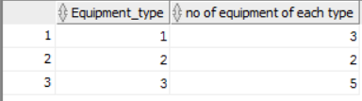

* 1. **SQL to get the number of CR created for each type 3 equipment**

|  |
| --- |
| select a.equipment_id ,a.EQUIPMENT_NAME, count(c.request_id)no_of_requests  from (select e.equipment_id ,e.EQUIPMENT_NAME  from equipment e where e.type=3) a  left outer join change_request c on (c.type_3_equipment_id = a.EQUIPMENT_ID )  group by a.equipment_id ,a.EQUIPMENT_NAME  order by a.equipment_id; |

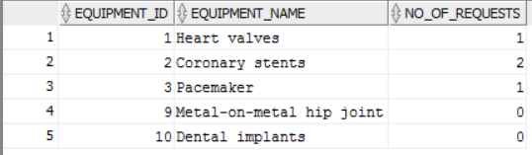

* 1. **View to check which CR is assigned to equipment**

|  |
| --- |
| create view vi_cr_equip as  select c.type_3_equipment_id , w.cr_id ,e.EQUIPMENT_NAME, e.DESCRIPTION from workflow w inner join change_request c on (w.cr_id = c.request_id)  inner join equipment e on (c.type_3_equipment_id = e.EQUIPMENT_ID) group by c.type_3_equipment_id , w.cr_id ,e.EQUIPMENT_NAME, e.DESCRIPTION;  select * from vi_cr_equip; |

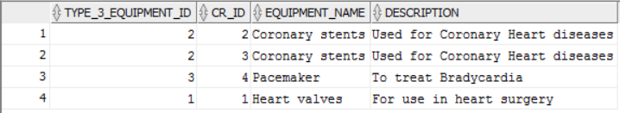

* 1. **SQL to get the Summary of the CRs created**

|  |
| --- |
| select c.request_id,c.create_date,e.equipment_id ,e.EQUIPMENT_NAME, e.DESCRIPTION,emp.Employee_name, c.cr_status from change_request c  inner join equipment e on (c.type_3_equipment_id = e.EQUIPMENT_ID)  inner join workflow w on (c.request_id = w.cr_id and assigned_by_id is null)  inner join Employee emp on (emp.Employee_id = w.assigned_to_id)  order by e.equipment_id; |

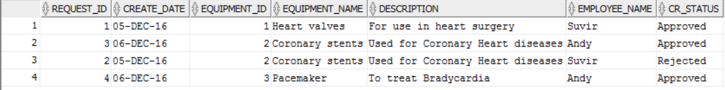

* 1. **Total time taken to close a change request**

|  |
| --- |
| Select w1.cr_id,  w1.start_date,  w2.finish_date,  (w2.finish_date - w1.start_date) total_time  From workflow w1, workflow w2  Where w1.cr_id = w2.cr_id  And w1.step_id = (SELECT MIN (w3.step_id)  From workflow w3  Where w1.cr_id = w3.cr_id)  And w2.step_id = (SELECT Max (w4.step_id)  From workflow w4  Where w2.cr_id = w4.cr_id);_id; |

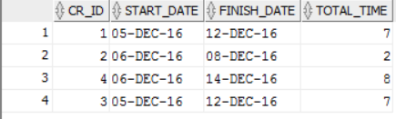

1. ***Conclusion***

In-order to comply with the new FDA Regulation, an additional database, linking the company’s internal database with the FDA database using the unique identifier has been created.

1. ***References***

<https://www.youtube.com/watch?v=wPS2ME-se2Q>

<https://www.explain-it.tv/de/referenzen/projekte/explain-it-handmade/roche-udi/>